**Multimedia Information Retrieval - Class Assignment 1**

**Name:** Filipe Fernandes Miranda **Student Number:** s1780581

**Answer 1**

Using 100 words I got a score of two out of five

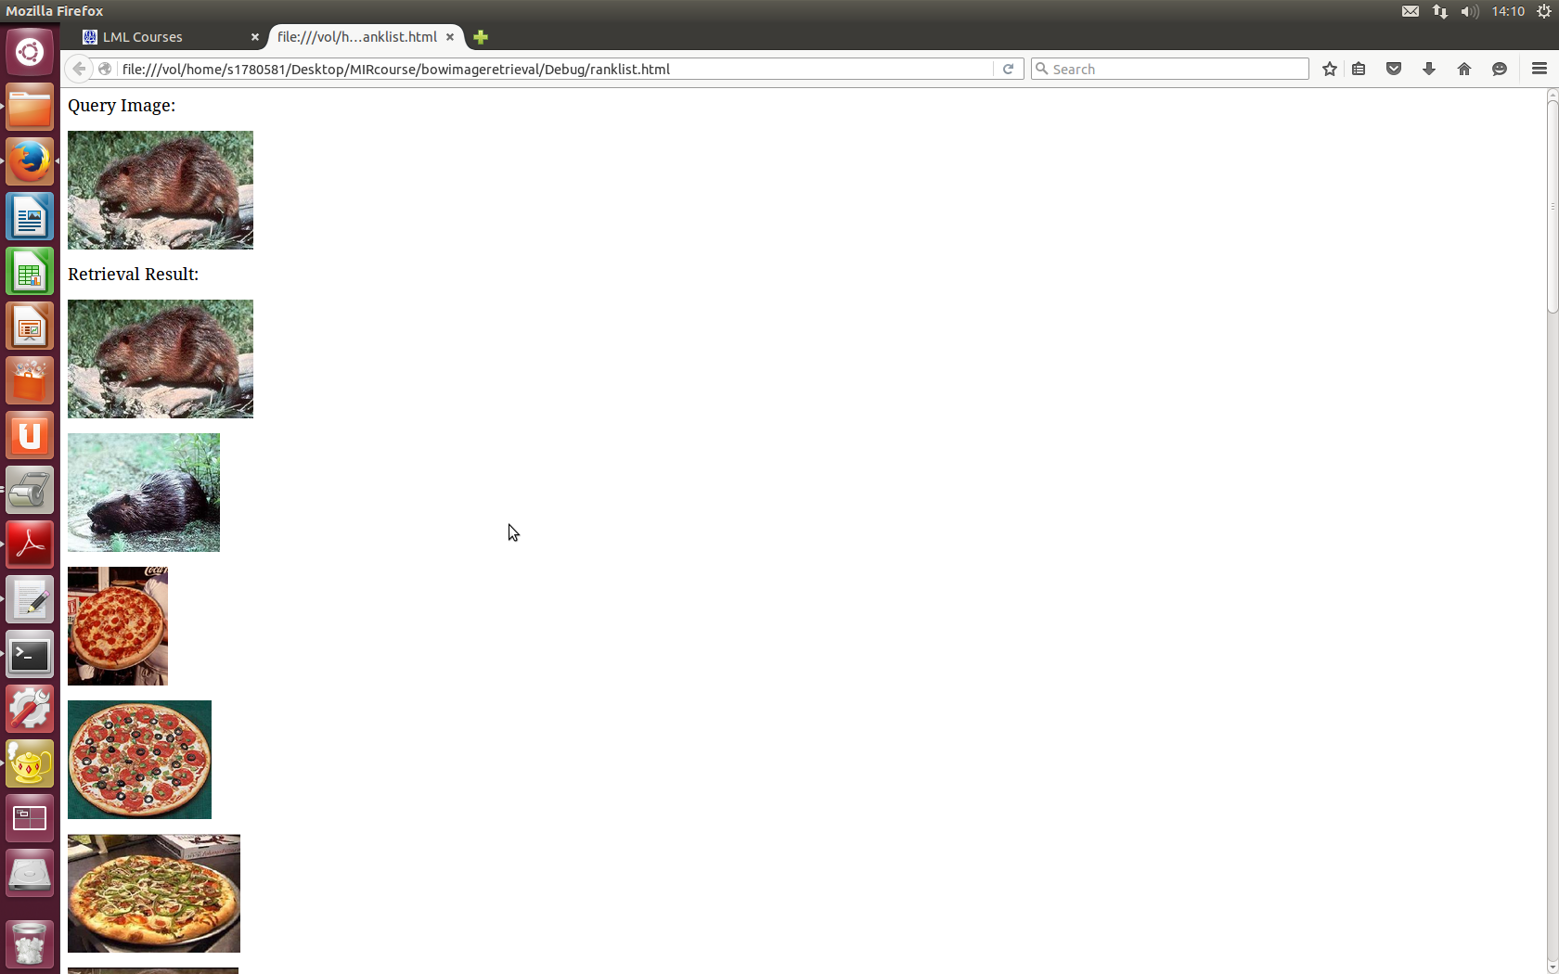

Using 15 words I got a score of three out of five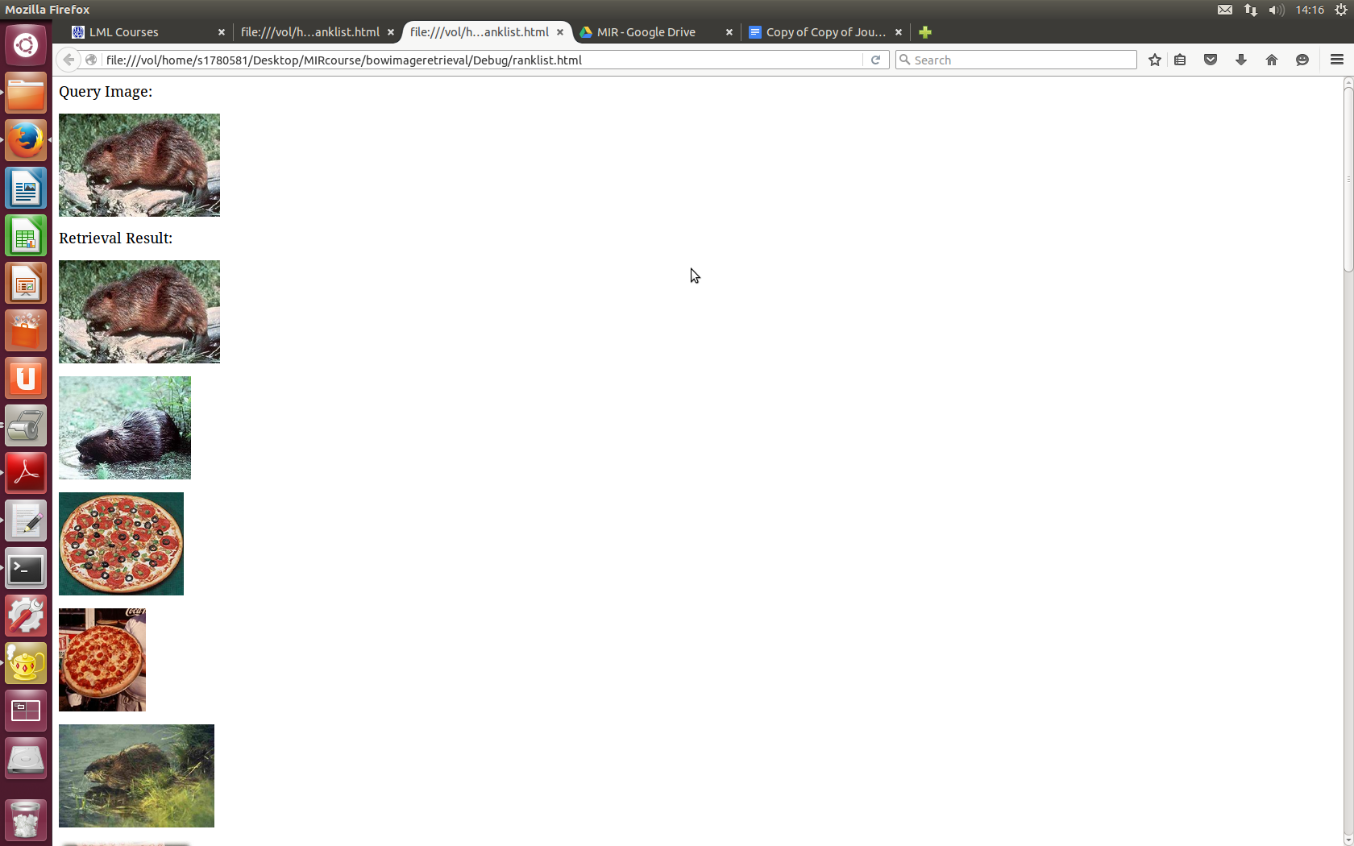

Using 2 words I got a score of one out of five

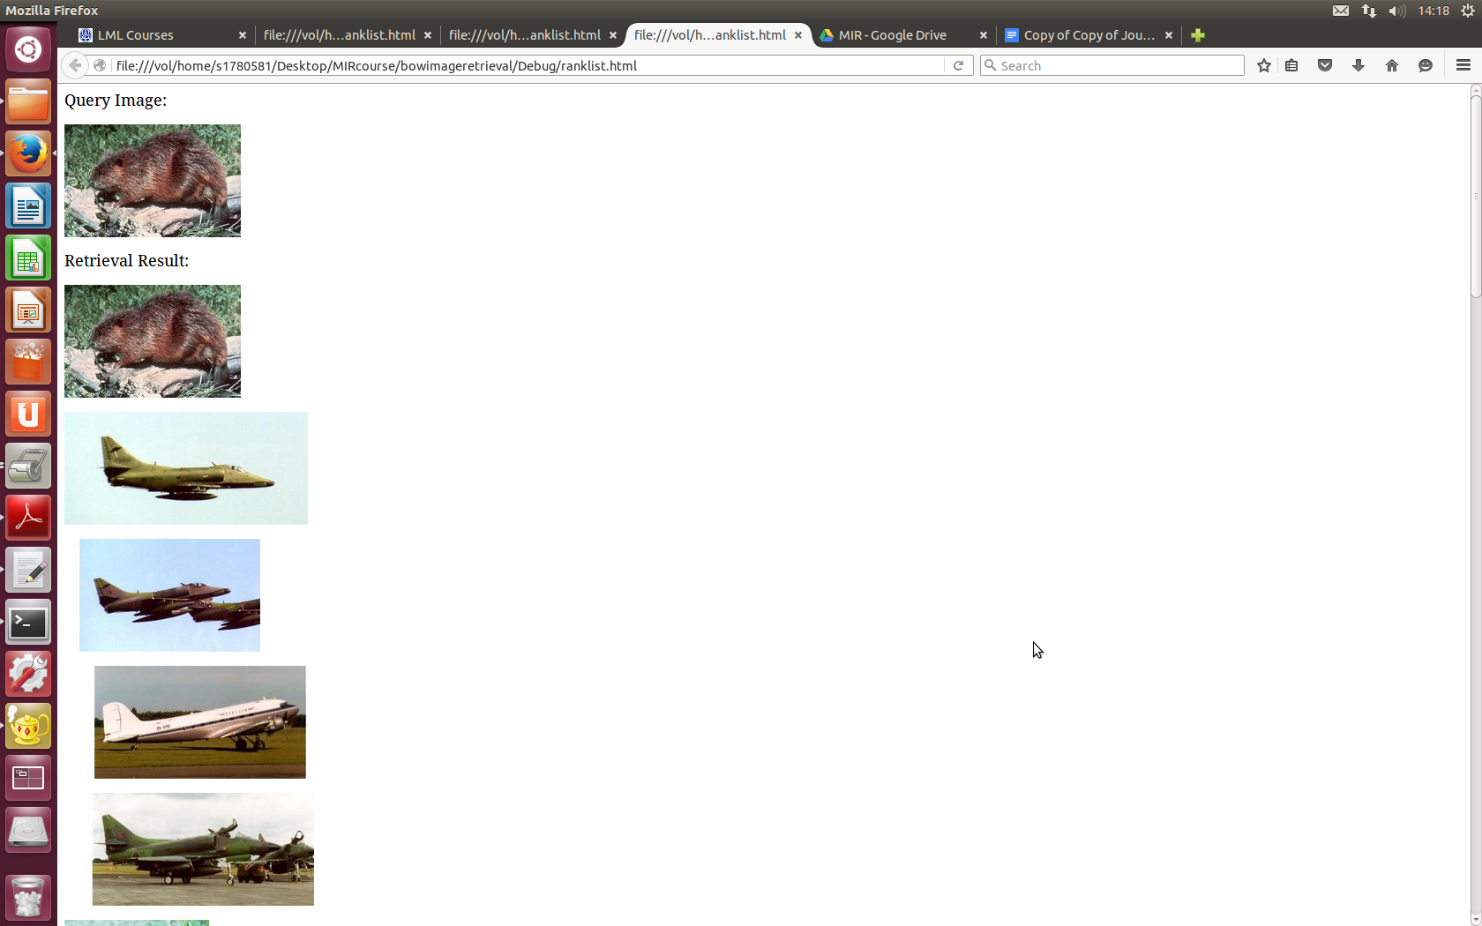

|  |  |  |  |  |
| --- | --- | --- | --- | --- |
|  | **Pizza** | **Beaver** | **Plane1** | **Plane2** |
| **2** | 1/5 | 1/5 | 4/5 | 4/5 |
| **15** | 3/5 | 3/5 | 5/5 | 4/5 |
| **100** | 3/5 | 2/5 | 5/5 | 4/5 |

**Answer 2**

**a)**

|  |  |  |  |  |
| --- | --- | --- | --- | --- |
|  | **Accordion** | **Wildcat** | **Soccer Ball** | **Score** |
| **2** | **Soccer Ball** | **Soccer Ball** | **Soccer Ball** | **1/3** |
| **15** | **Accordion** | **Wildcat** | **Soccer Ball** | **1** |
| **100** | **Accordion** | **Wildcat** | **Soccer Ball** | **1** |

**b)**

|  |  |  |  |  |  |  |
| --- | --- | --- | --- | --- | --- | --- |
|  | **Accordion** | **Wildcat** | **Soccer Ball** | **Labrador1** | **Labrador2** | **Labrador3** |
| **2** | **Soccer Ball** | **Accordion** | **Soccer Ball** | **Accordion** | **Soccer Ball** | **Soccer Ball** |
| **15** | **Accordion** | **Wildcat** | **Soccer Ball** | **Wildcat** | **Wildcat** | **Wildcat** |
| FP |  |  |  |  |  |  |
| FN |  |  |  | xx | xx | xx |

FP-> false positive

FN->false negative

I had six false negatives since the program said it was a something else other than a labrador. A false positive would be if for example the program said it was a labrador and it was in fact an accordion.

The bowl classification was actually better for all the classes but the golden retriever. That maybe because we have fewer training images or that the “wild cat” maybe has an histogram similar to the “golden retriever”.

The program running:

